# Project Description

## **Overview**

Our project for assignment 3 will be the development of an application to be used in the Childcare industry of Australia to monitor and track the required observations of learning outcomes for children in a day care setting.

In the Child Care industry each child’s learning outcomes are assessed on a monthly basis which is primarily a manual task. Our project deliverable is to design and develop a Java application that will be to be used across multiple platforms that aims to reduce the amount of time spent on paperwork and thus allowing educators to focus their time on children, improving their education experience.

.

This project will involve work in several IT areas including:

* Developing the application using a Java IDE
* Server-side knowledge for hosting and potential data storage
* Using a GitHub repository to store and access the project files
* Applying a testing and QA methodology to identify any issues and provide a feedback on changes
* Providing an easy to use and effective UI experience
* Implementing secure data security, storage, and encryption for private information

## **Motivation**

Currently in Australia there are more than 15,000 childcare and education services that operate under the national quality framework. Workers across these services must record the observations of multiple learning outcomes for each child in their care, today this is a manual process which involves tracking these observations manually.

Improving the working capacity of employees in an essential industry by providing an alternative that is easy to learn and use for all users, regardless of background of IT knowledge is a key motivation for our team and this project.

Providing an easy to use mobile application – or application that can be used across multiple devices – to replace potentially redundant manual work is something that is all too familiar in today’s IT landscape. Improving business processes and ways of working is a key aspect of Information Technology and targeting an industry as critical as child care in Australia will provide a lot of exposure and potentially a lot of users.

Technically using a programming language such as Java and utilising a cloud storage option providing essentially 24/7 availability is becoming the norm with most applications in the IT industry.

Completing this project would demonstrate to a future employer a number of positive aspects:

* Competency in a commonly used development language (Java)
* Knowledge in maintaining storage of data – and potentially exposure to encryption and various aspects of data security
* Working effectively in a team – assigning tasks, high-level communication and escalation management
* Showing initiative in learning new skills and exploring what options are available for designing and completing a project

## **Landscape**

What similar systems or products are available? What competitors are there? What points of difference are there about your project compared to what exist now? *At least one paragraph is expected.*

## **Detailed Description**

### Aims

The aim of our application is to make redundant the manual work that is currently done to record observations of learning outcomes in day care centres. These outcomes must be recorded per child throughout the course of a year at these centres, some 15,000+ across Australia, which results in loss of time spend educating children. Recording and maintaining almost any sort of vital information in any industry should be looked at as potentially an issue – user error, damage and even storage of paper-based sensitive information can be hazardous and poses an unnecessary risk when compared to the alternatives an IT solution such as our application could offer.

Our aim is to be the primary used application across day care centres in Australia for recording these observations, essentially being a market-leader due to the current lack of competitors in the field and because of the innovation and updating of current business processes we will target,

The first goal must be to provide a practical and intuitive UI as our target market is potentially end-users with limited or no IT knowledge and background. The application must be easy to use and incorporate into every-day practice – users must clearly see the benefits of adopting a new solution or tool to ensure a high level of user adoption. Disrupting an industry-wide practice regardless of the potential positive impact is very challenging and without an easy to use application we risk not making it past an early hurdle.

Ongoing development and future scalability of features means that the application must be developed in a well-know, robust programming language. Because of this the design up until this point has been done in Java. This should somewhat ‘future-proof’ the application in regard to maintaining code as well as potentially expanding the scope of the application and even having other developers review and contribute to the code. Java is a very common programming language that is widely used in the development of applications – so we are reducing the risk of developing in a language that may become outdated or sub seeded by another programming language (or tool) in popularity.

Due to the industry that the application is targeting another goal will be to ensure that all government regulations and requirements relating to the childcare industry and the use of technology are met. Regulations and processes around storing of sensitive and personal data (names, addresses, age etc) along with how this information is encrypted and accessed are key areas that will require on-going attention. Our goal is to ensure that the application is flexible enough from a development standpoint that the ever-evolving regulations and rules can be met and any changes aren’t detrimental to the application – or would result in long-term downtime of the application.

### Plans and Progress

Here you should give as much detail as you can about what your project will do, and how you will do it. This should also include how far you have got with developing any features or outcomes from your project. Tell us about the “story" of your project – how it began, how it has progressed, and what stage of the plan you are up to. Include any dead-ends you may have followed, decisions made, and changes that have been made to the project plan. This will need to include a significant amount of detail, so that it is easily seen what precisely you have done and are planning to do. If it helps, imagine the information that would be required if you were to hand this project over at the end of the semester to a new team to complete the job. What would you want to know, if you were one of the people taking over? *There is no set length for this section, but it is hard to believe that less than two pages could be adequate. Three or four pages is far more likely.*

1. ***How application began – history and background***
2. ***What has progressed since Assignment 2?***

* Significant development work
* UI update

1. ***Tools used for development and development process?***

The primary tool that has been used is Java SE Development Kit (JDK) which is a software development environment used for development of Java applications. Our team has also continued to use a Git Hub repository, so all members have access to the project files, and the ability to make changes, complete testing, and quality assurance throughout this project phase.

Although not a development tool, Microsoft Teams has been extensively utilised throughout the project. Teams has allowed the entire group to stay in regular communication, used to assign deployment tasks and provide feedback and updates to other team members. Project management is a key and potentially underestimated aspect of a development project, keeping on top of tasks and admin work is vital to ensure that deadlines can be met.

1. ***What stage are we at now that Assignment 3 has finished?***
2. ***Development problems that have been encountered (ask Ryan)***

Due the fact the application has been developed using Java ensuring backwards compatibility with older Java versions has been something that we need to consider. For example a project compiled on the latest version of Java won’t run on an older version of Java – which shouldn’t be an issue for people with a background or knowledge in IT, however in the wider context of the project would mean that all devices utilising the application would have a minimum version requirement. This is challenging as is it can be somewhat out of the hands of our team once an end-user(s) starts using the application. Ensuring users update their devices is not an uncommon problem for applications, however this could potentially be a serious challenge.

Another key issue which has impacted the development of the application has been keeping in line with the national framework used by the childcare industry in Australia – these requirements and regulations are constantly evolving and means that any changes to the application (data storage, form information, observation notes, etc) might need to be made at short-notice. Most applications and projects have a roadmap based on ideas and innovations they wish to see in the future, however we would need to ensure that some future capacity is designated to the possibility of this framework changing.

1. ***Any changes from the original idea? (Ryan)***

**Ryan:** My original idea was an app that can provide a way to track the learning outcomes for a particular observation for a child digitally thus reducing time and paper work.  I feel that is still there it has just evolved to match the current needs and environment.

1. ***Testing and QA process in Assignment 3***

Given that the project had to be completed in a fairly short amount of time along with the fact that there were a number of development changes and subsequent testing, we required a proven testing & QA methodology to follow to ensure that a robust and well tested application was the end result. Several popular methodologies were considered (Agile, Waterfall, Extreme programming) however we decided that the iterative method would be the most effective for a project of this size and number of team members.

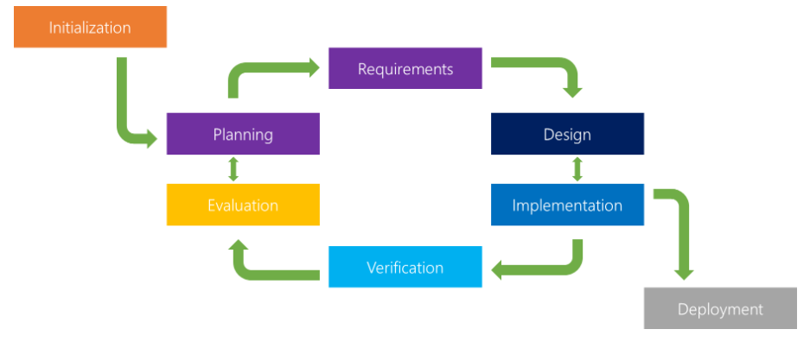

Figure 1 Example Iterative QA Methodology Workflow

Following assignment 2 we had an initial version of the Childcare Observations application – this meant that for the planning & requirements we could simply build on the original version and add a subset of requirements and goals that would be targeted for assignment 2.

During the assignment there were a number of iterative changes made to the application (Code changes, UI changes, changes to executable file) which resulting in a various ‘cycles’ of the QA process to ensure that all changes were tested, verified and evaluated by the team before any further changes were planned and developed.

The strength of this QA process is that it allows for smaller, ongoing changes to the application to be completed and tested prior to the final deployment. This means that any issues or bugs with the changes or usability of the application are identified quickly and are less likely to impact a final deployment or deadline.

1. *Future plans and opportunities to improve application*

Several improvements to the application that could be targeted in the future have been identified and also incorporated into our extended timeline (+10 weeks). The improvements

* **Improved Program UI**
* **No pop-up windows – program to run in 1 window**
* **Save securely to a secure file type**
* **Help files/menu**

### Roles

It is sometimes useful to define roles for particular participants, such as Lead Developer, or Technical Designer, or User Interface Designer. It is also possible that roles are changed from week to week, depending on what needs to be done next. Have you defined any specific roles for your project? If so, describe and justify these. If not, describe your process and justify why there are no specific roles.

* **Development (Multiple Roles)**
* **Project Management**
* **Testing and QA**

### Scope and Limits

*“There's no such thing as perfection. You're never finished with a film. You run out of time.” -- Peter Jackson, director of `The Lord of the Rings’ and ‘The Hobbit’ trilogies*

One of the more difficult parts of project planning and execution is to define the scope and limits of the project. As mentioned above, you never really complete project like these; all you can ever do is your best in the time available. Part of that involves setting priorities and accepting that there will be features that will take too long to develop. This means that it is important to set a scope for your project, as a means of ensuring that you make the most of the time available. For example, if you are developing a game, you might consider only producing one level and two or three characters, in order to show a proof-of-concept, rather than develop three levels and ten characters.

The scope is probably the most crucial part of your plan, and also the most difficult to define. One way to define the scope is to think of the deliverables for your project, i.e. what outcomes would you be able to show to someone who asks you to see the results of your work. This will also include several statements about what will not be part of the project. For example, if you are using Open Street Maps to show the location of all your favourite shops, the deliverables would include the updated map, but not the Open Street Maps technology itself. It would also not include many other features of Open Street Maps, or other interesting location -- just those which show your favourite shops.

Also, be aware of the phenomenon of `scope creep', which is the tendency for projects to incorporate more and more features. There is nothing wrong with being ambitious, but you only have a certain amount of time. At least one paragraph is expected.

* **In scope v out of scope diagram. Out of scope would be future items we intend to include.**

### Tools and Technologies

What software or other tools are required by the project? Are there any software licenses needed? Is there any hardware needed (beyond a standard laptop or something similar)? This needs to be precise (e.g. Windows Movie Maker Version 45.3) but needn't be long. You should also include a brief description of any prior experience any group members have had with the tools and technologies you list. *There is no minimum length for this. It is important to be as precise as possible, but descriptions of the tools are not needed here.*

* **Java**
* **Word, PDF**
* **Any prior experience for members?**

### Testing

How will your test your project? How will you know when you have succeeded? Testing is not something that you should leave until the very end; often it is far more useful to have a quick and dirty “mock up" of a project and then do some (limited) testing, to and out whether you are building the right product. If your project involves user testing, you should describe in your plan how you will find the test users, approximately what number of people you will need, and what background (if any) is required. *At least one paragraph is expected here.*

* **Ongoing Testing plan & feedback required (refer to Plans & Progress: Testing section and possibly reuse some aspects)**

### Timeframe

Another difficult aspect of project planning is knowing how much time to allow. You will have something like 36 hours per person for this assignment. In order to develop a plan for further work beyond the end of this course, let us assume that you will have an extra 10 hours per week per person for 10 weeks in addition to this time in order to develop your project. This means that you will have six weeks (Weeks 7 to 12) of the semester to work on your assignment, with a further 10 weeks after that. This means that your plan will be for a total of 15 weeks, with the first 6 being on this assignment.

You will clearly not have the extra 10 weeks to work on the project; this is intended to give you a feeling for how much you would be able to achieve in that time. This means that the first 6 weeks of your timeline will end up being your actually progress on this project, with the remaining 10 weeks being your plan for the next stages.

*This should be presented in the form of a table, with one row for each week, specifying as best you can the work for each person for each week.* This means that the first six rows of the table will describe your progress so far, and the remaining 10 your best guess at how the remaining time would work.

This will no doubt change as you work on your assignment, as it will give you a more precise idea about how long it will take to get things done. This is not an unchangeable contract for exactly how things will work; that is unrealistic for just about any project. The idea is to get you thinking about how exactly your time should be allocated to the various tasks involved. It is a good idea to have a milestone (i.e. a specific outcome) for each week of the project. This may include getting familiar with tools, or reading up on a particular technique or technology. You should also include time for writing up the final report and any other documentation. Writing reports always takes longer than you think, especially as you should expect to re-write any piece of writing that you do at least three or four times.

* Use timeline from PowerPoint

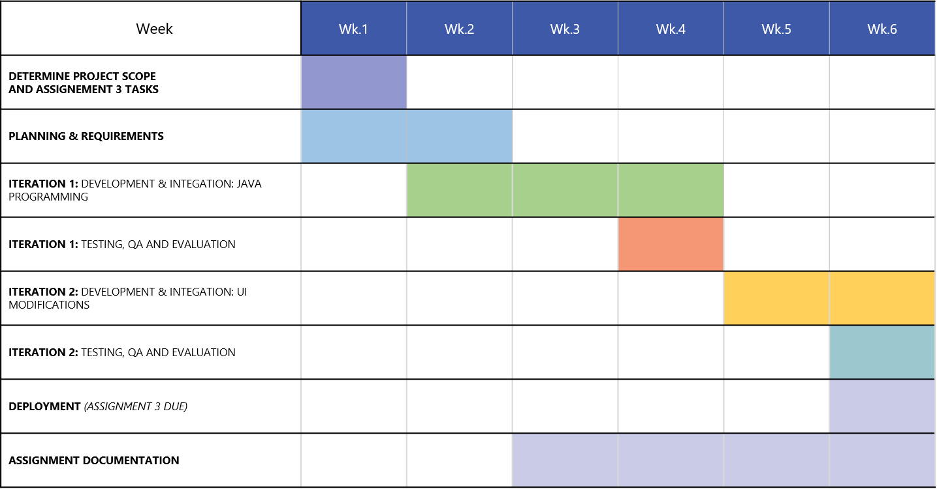

**Future Plan to Improve Application:**

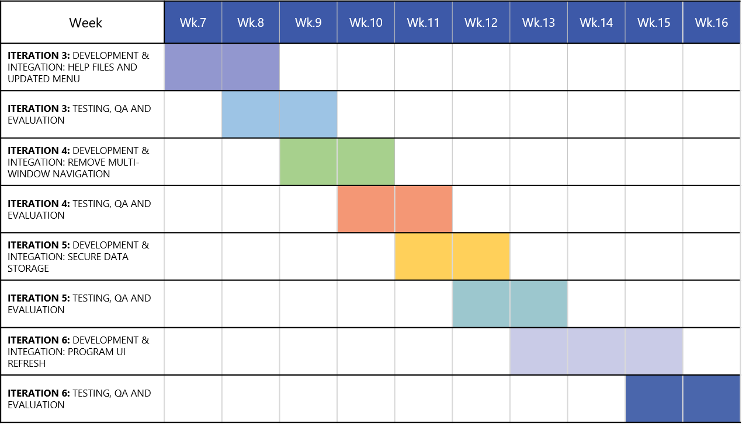

### Risks

What risks can you identify for your project? There will always be some generic risks (such as computers breaking down the night before a deadline, health and family issues, and institutional changes). Do not include generic risks such as these. The idea is to be as specific as you can to your project. For example, if your topic is to develop a game, there may be a risk that the software you choose to work with may be very difficult to learn, poorly documented, or not turn out to have the features that it claims it has. These properties are often only discovered once you have started working with the software, and so unless you have had lots of experience with the particular tool, there is always a risk that it may not work as well as you believe it should, no matter how much prior research you do. Similar comments apply to hardware

.

* **Changes in childcare industry – especially impacted during COVID restrictions**
* **Changes in Gov’t regulations (data storage, childcare policies)**
* **User Adoption: implementing change especially around**
* **Minor: server/hosting issues**

### Group processes and communications

Communication between group members is arguably the most important aspect of your project. Past experience has shown that communication breakdowns between group members is the most common cause of project failures, so it is vital that you specify at the outset the means and expected frequency of communication between group members. How will your group communicate? How often will meetings take place? Will these be face-to-face, or using technologies such as Skype? Or Facebook? Or email? Or text? Or ... ?? What will you do if you have a group member who does not respond to communications? You should expect contact between group members at least twice a week. You can always make contact more often if you wish, but you do need to know what minimum frequency is expected from all members of your group. *At least one paragraph is expected here.*

* **Communication and PM tools – Microsoft teams, Asana.**
* **Escalation and dealing with people who don’t respond to messages or requests/work that has been assigned**
* **Online communication (due to distance course, team members living in different cities)**